## **ZIGBEE DEVELOPMENT KIT**

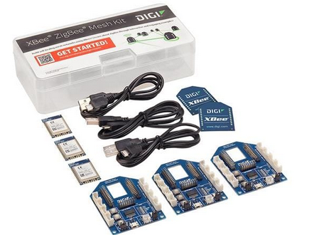

**Specifications**

DIGI XBee® XB24 ZigBee Thread-Ready RF Modules provide a larger memory capacity to enable designers to upgrade to the Thread networking protocol. The Thread-Ready RF Modules maintain the proven benefits of previous XBee versions, but with a higher memory EM3587 chipset. These modules offer 512kB flash memory, which allows for full implementation of the Thread networking protocol for end nodes and routers. The XBee® XB24 ZigBee Thread-Ready RF Modules are ideal for use in wireless industrial applications.

## **FEATURES**

* Thread updatable for maximum flexibility
* Transceiver chipset: Silicon Labs EM3587 SoC
* 16 channels
* ADC Inputs: (4) 10-bit ADC inputs
* Digital: I/O 15
* Data Rate: RF 250Kbps, Serial up to 1Mbps
* 2.1 to 3.6V Supply Voltage
* Transmit Power: 3.1mW (+5dBm) / 6.3mW (+8 dBm) boost mode
* Transmit Current: 33mA @ 3.3VDC / 45mA boost mode
* Receive Current: 28mA @ 3.3VDC / 31mA boost mode
* Power-Down Current: <3uA at 25ºC
* Receiver Sensitivity (1% PER): -100dBm / -102dBm boost mode
* Serial Data Interface: UART, SPI
* Configuration Method: API or AT commands, local or over-the-air (OTA)
* Frequency Band: ISM 2.4GHz
* Interference Immunity DSSS (Direct Sequence Spread Spectrum)
* Antenna Options: Through-Hole: PCB Antenna, U.FL Connector, RPSMA Connector, or Integrated Wire SMT: RF Pad, PCB Antenna, or U.FL Connector
* Operating Temperature: -40°C to +85°C
* Dimensions (LxWxH) and Weight: SMT: 0.866x1.33x0.120 inches (2.199x3.4x0.305cm)